Explanation of the running of q1.c :

Output after editing the code:

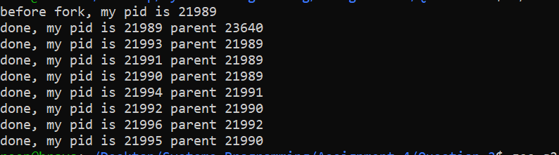

Diagram:

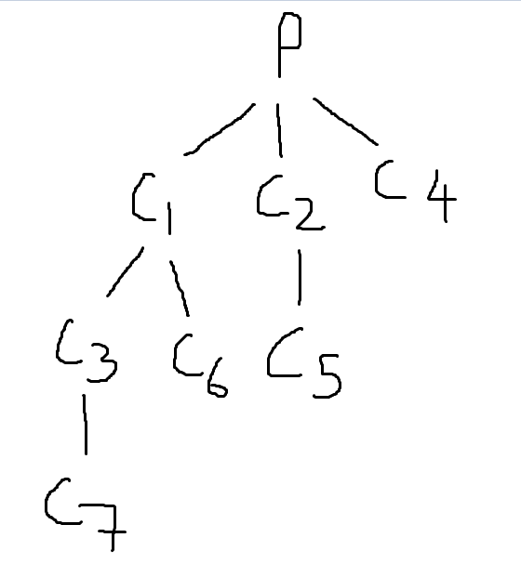

Explanation of q2.c :

Output after editing the code:

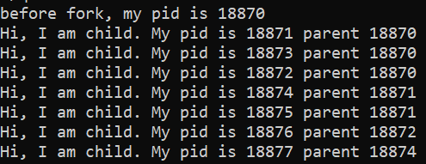

Diagram:

